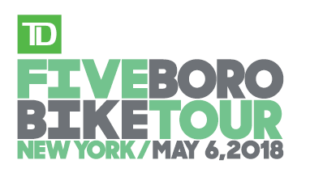

**PROXY PACKET PICKUP FORM**

RIDER NAME _________________________________________________________________

(Please print legibly)

I hereby appoint:

PROXY NAME _______________________________________________________________

(Please print legibly)

as my proxy to pick up my Rider Packet at Bike Expo New York for the 2018 TD Five Boro Bike Tour Presented by REI.

DATE _______________________________________________________________________

RIDER SIGNATURE ___________________________________________________________

INSTRUCTIONS FOR RIDER

Provide your proxy with the following items:

* Completed and signed Proxy Packet Pickup form
* Photocopy of your photo ID
* Print-out of your barcode (If you did not opt out of receiving your barcode via text, you can also forward the text containing your barcode to your proxy.)

INSTRUCTIONS FOR PROXY

Bring all of the aforementioned items, as well as your own photo ID, to Bike Expo New York on May 4-5, 2018, at Pier 12, Brooklyn Cruise Terminal, Brooklyn, NY to pick up the proxy packet. Visit [**www.bike.nyc**](http://www.bike.nyc) to learn more.

*INDIVIDUALS (INCLUDING NON-RIDERS) MAY PICK UP A MAXIMUM OF FIVE (5) PROXY PACKETS.